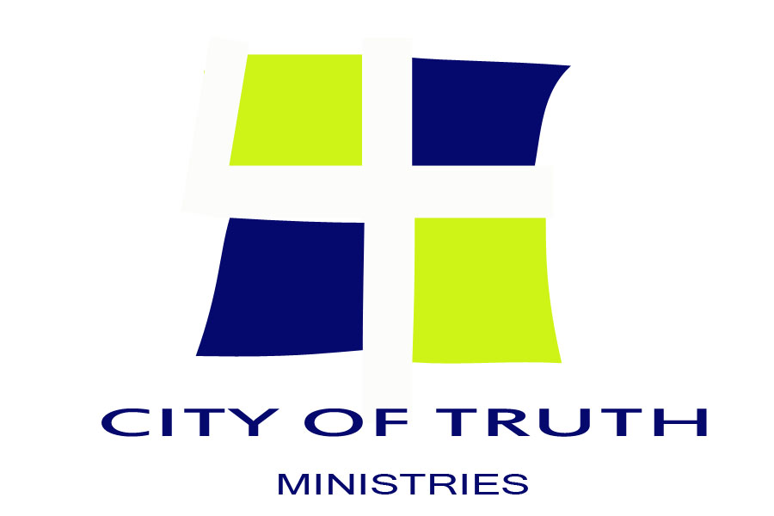

“A MIND OF CHRIST”
An Overview of our Education
The Education Department is broken into two basic areas, Individual Bible study and Group Bible study. Each student goes through 3 separate phases including: Induction Phase, Training Phase, and Transition Phase.
Induction Phase
Induction consists of orientation, introduction to Salvation, and John’s ministry through his Gospel as he introduces us to Jesus Christ. This is where the students identify areas where they need to change the way they think and act.
Training Phase
The Second Phase is where the students learn life skills by using the principles as taught in God’s Word.
Transition Phase
The third phase is where students develop an exit strategy and prepare for transition back into the community.
Individual Bible Studies – IBS
Each student comes to City of Truth Ministries with different backgrounds and issues. IBS is where the Educational Coordinator, together with the student’s advisor assigns different studies that are tailor made for each student, focusing on their needs and issues. This is done through the five different studies described below.
- Bible Reading Class – Students are required to read the Bible daily.
- Scripture Memory – Students are required to memorize Scripture assignments.
- Character Quality – Students learn new character qualities such as, Meekness, Humility, Tolerance
and Self control.
- Bible Lessons – Students study scripture to help understand how to take God’s principles and apply
them to their personal relationships.
- Personal Reading – Students are encouraged to read approved books as the Bible and other Christian books enhances their understanding of the world.
Group Bible Study – GBS
The Christian Community is crying for practical Biblical teaching to help prepare us to meet the problems
we face in our daily living in today’s society. The curriculum City of Truth teaches was developed to introduce a broad range of issues essential to Christian living, and get a person involved in actively applying these Biblical principles in daily situations.
Last revised 08/21/16
This group of studies teaches practical ways to apply Biblical truths to the challenges facing Christians in these troubles times.
How Can I Know I’m a Christian? – You will discover how to become a Christian. You will also find out where to look for evidence that you are a Christian and how to develop a personal relationship with Jesus, thorough this you will find out what to do about doubts.
A Quick Look at the Bible – A general introduction to the Bible. How does Christ fit into the whole Bible? Attitudes – What are attitudes? How do we develop new attitudes? What is the right attitude to have
when being criticized or corrected?
Temptation – What is temptation? Why do Christians get tempted? How can we prepare for temptation?
Successful Christian Living – What does God say about how you can be a successful Christian? What does the Holy Sprit do in your life when you are a Christian?
Growing Through Failure – What causes failure? What God does when you fail? Steps to recovery from failure. The role of forgiveness and restitution in recovery.
Christian Practices – A study of six subjects on the church and its practices.
Obedience to God – Why should you obey God? What are God’s greatest laws? What are the results of obeying and disobeying God?
Obedience to Man – Why should you obey your leader? Introducing guidelines on obeying your leader with love.
Anger and Personal Rights – Discusses why we get angry and how we express our anger. What are some practical ways to deal with your anger?
How to Study the Bible – Basic teaching on how and why to study the Bible. What are the three basic steps of Bible study? Three simple methods of studying the Bible are presented.
Love and accepting Myself – What is love? What does the Bible say about love? What does it mean to accept yourself? What are the steps to developing a positive image?
Person Relationships With Others – Discuss how to be a good friend and how to develop different kinds of friendships. What should you do about non Christian friends?
Spiritual Power and the Supernatural – What is true spiritual power and how it can have a practical impact on the life of the new Christian.
Last revised 08/21/16

